Open Handed

Code:-

import matplotlib.pyplot as plt
import numpy as np
from scipy.signal import butter, cheby1, freqz, lfilter
import librosa
import soundfile as sf
import requests

def download_song(url, filename="input_song.mp3"):
"""Download MP3 from the given URL"""
response = requests.get(url)
with open(filename, "wb") as f:
f.write(response.content)
print(f"Downloaded song: {filename}")
return filename

def design_butterworth_filter(filter_order, cutoff_frequency, sampling_frequency):
nyquist_frequency = sampling_frequency / 2
normalized_cutoff = cutoff_frequency / nyquist_frequency
digital_b, digital_a = butter(
filter_order, normalized_cutoff, btype="low", analog=False
)
return digital_b, digital_a

def design_chebyshev_filter(filter_order, cutoff_frequency, sampling_frequency, ripple):
nyquist_frequency = sampling_frequency / 2
normalized_cutoff = cutoff_frequency / nyquist_frequency
digital_b, digital_a = cheby1(
filter_order, ripple, normalized_cutoff, btype="low", analog=False
)
return digital_b, digital_a

def plot_filter_response(digital_b, digital_a, sampling_frequency):
frequency, magnitude_response = freqz(digital_b, digital_a, fs=sampling_frequency)

plt.figure(figsize=(10, 6))
plt.plot(frequency, 20 * np.log10(np.abs(magnitude_response)))
plt.title("Filter Magnitude Response (dB)")
plt.xlabel("Frequency (Hz)")
plt.ylabel("Magnitude (dB)")
plt.grid(True)
plt.show()

def apply_filter_to_audio(input_file, output_file, filter_b, filter_a):
audio_data, sr = librosa.load(input_file, sr=None) # load MP3
filtered_audio = lfilter(filter_b, filter_a, audio_data)
sf.write(output_file, filtered_audio, sr)
print(f"Filtered audio saved as: {output_file}")

# Plot waveforms
plt.figure(figsize=(12, 6))
plt.subplot(2, 1, 1)
plt.plot(audio_data)
plt.title("Original Audio Waveform")
plt.xlabel("Samples")
plt.ylabel("Amplitude")

plt.subplot(2, 1, 2)
plt.plot(filtered_audio)
plt.title("Filtered Audio Waveform (Low-Pass)")
plt.xlabel("Samples")
plt.ylabel("Amplitude")
plt.tight_layout()
plt.show()

filter_order = 4
cutoff_frequency = 1000
ripple = 0.5

song_url = "https://www.soundhelix.com/examples/mp3/SoundHelix-Song-1.mp3"

input_mp3 = download_song(song_url)

y, sr = librosa.load(input_mp3, sr=None)

b_butter, a_butter = design_butterworth_filter(filter_order, cutoff_frequency, sr)
plot_filter_response(b_butter, a_butter, sr)
apply_filter_to_audio(input_mp3, "butter_filtered.wav", b_butter, a_butter)

b_cheby, a_cheby = design_chebyshev_filter(filter_order, cutoff_frequency, sr, ripple)
plot_filter_response(b_cheby, a_cheby, sr)
apply_filter_to_audio(input_mp3, "cheby_filtered.wav", b_cheby, a_cheby)

Output :-

Butterworth Filter Magnitude Response :-
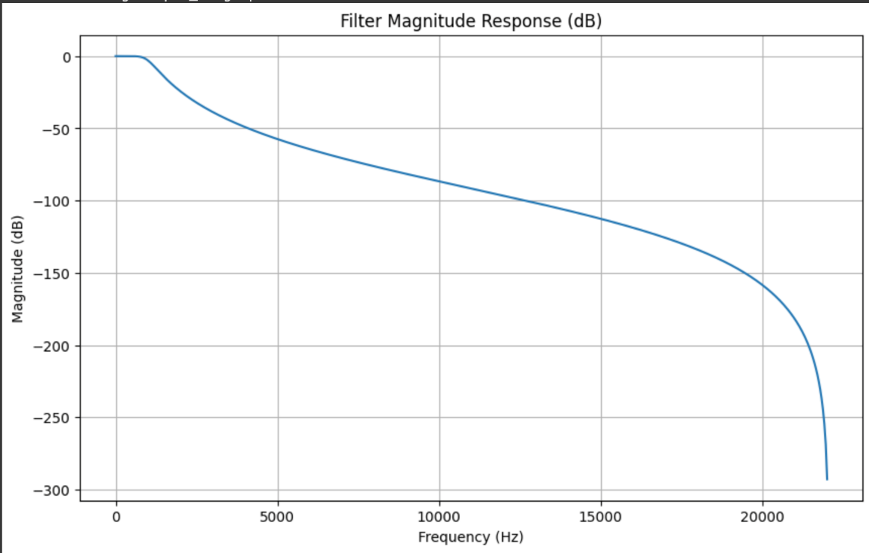

Original audio Waveform Vs Filtered Audio Waveform(Low Pass) :-
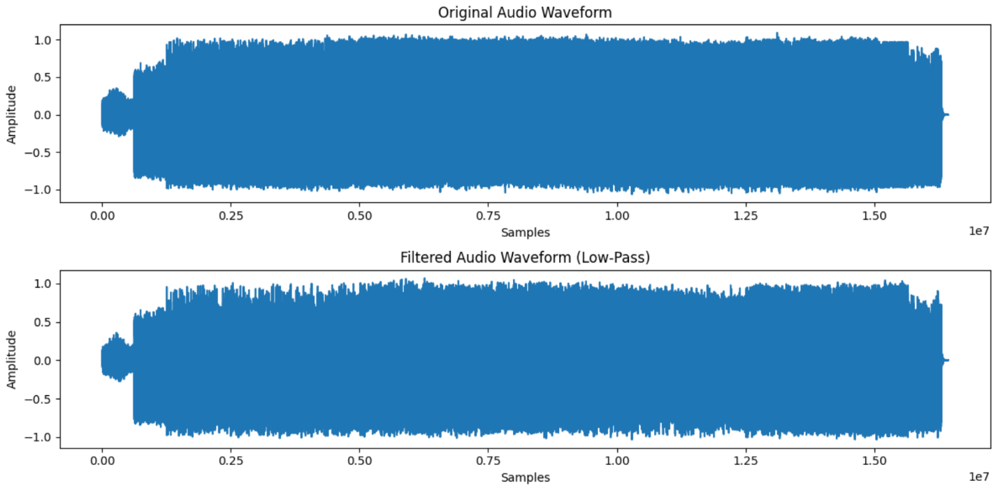

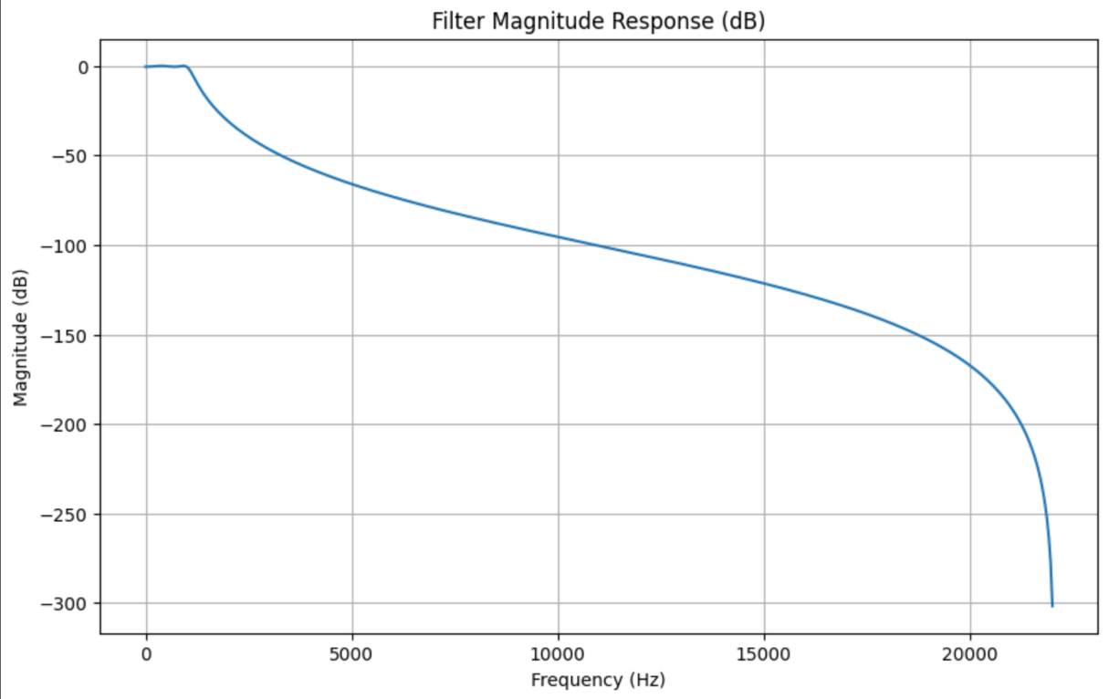
Chebyshev Filter Magnitude Response :-

Original audio Waveform Vs Filtered Audio Waveform(Low Pass) :-
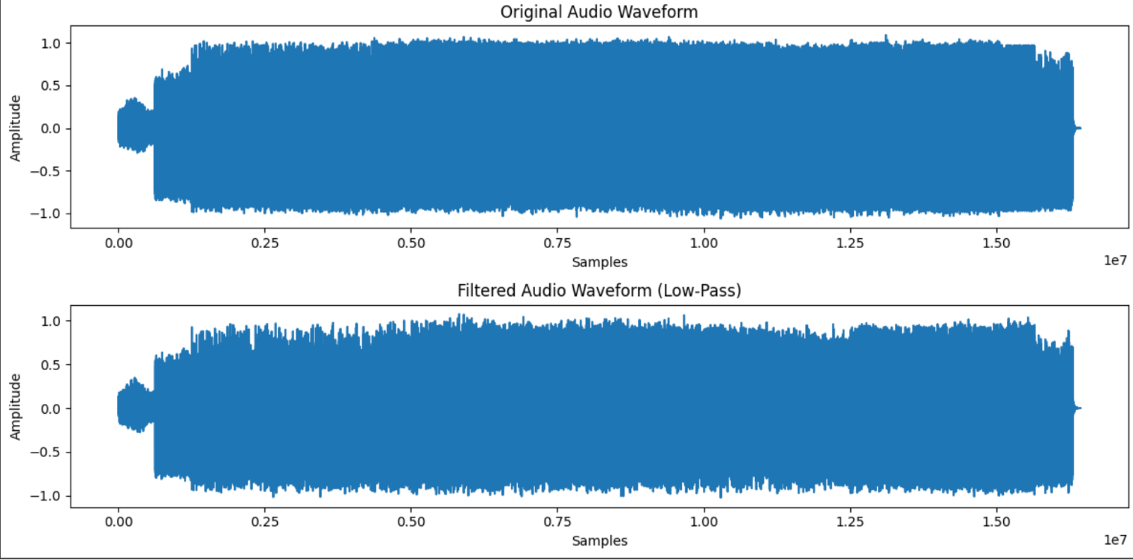

Observation:
- The Butterworth filter exhibited a flat passband with no ripples and a smooth roll-off. When applied to the audio, high-frequency components were attenuated gradually, preserving the natural quality of the signal.
- The Chebyshev filter provided a sharper cutoff than the Butterworth filter, but introduced ripples in the passband. In the audio output, high frequencies were suppressed more strongly, but the signal showed slight distortion due to ripple effects.
- The waveform plots clearly showed the difference between the original audio and the filtered audio, where the filtered signals had reduced high-frequency variations.
- The frequency response plots verified the expected characteristics: Butterworth being maximally flat and Chebyshev having ripples with a steeper transition.
- The bilinear transformation method successfully enabled the conversion of analog filter design into digital implementation for audio processing

Conclusion:
We learned in this open handed experiment how to design and apply Butterworth and Chebyshev low-pass digital filters to real audio signals using the bilinear transformation method. The Butterworth filter is more suitable when smoothness and minimal distortion are required, while the Chebyshev filter is preferable when a sharper cutoff is desired, even with some ripples. This shows the practical importance of filter choice in digital signal and audio processing applications.

